**Setting GRE & VXLAN Tunnels between two different Mininet topologies:**

*Problem statement - To be able to connect two topologies together (tunneling together) that are created using two different Mininet-VMs. Essentially, be able to ping a host which is located in one Mininet-VM using another host which is in a different Mininet-VM. A diagram to visualize this scenario is given in Figure 1.*

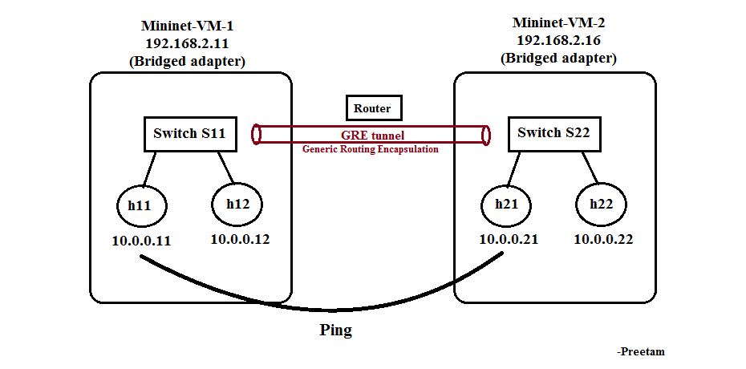

Figure 1

**Steps :**

1. Start two Mininet VMs with Network Adapter set as Bridged Adapter, use ifconfig to retrieve IP addresses of respective Mininet VMs (required for setting up tunnels).
2. Perform $ sudo mn -c
3. Now create two separate topologies in respective Mininet VMs. For that navigate to $ cd /mininet and use $ vi Custom_topo.py command to create and edit the python file.

|  |
| --- |
| # Custom_topo.py file in Mininet-VM-1  import pdb  from mininet.topo import Topo    class MyTopo( Topo ):    def __init__ ( self ):  "Create custom topo."    # Initialize topo  Topo.__init__( self )    # Add host and Switches  S1 = self.addSwitch( 's11' )  H1 = self.addHost( 'h11', ip="10.0.0.11")  H2 = self.addHost( 'h12', ip="10.0.0.12")  self.addLink(H1, S1)  self.addLink(H2, S1)    topos = { 'mytopo': ( lambda: MyTopo() ) } |

|  |
| --- |
| # Custom_topo.py file in Mininet-VM-2  import pdb  from mininet.topo import Topo    class MyTopo( Topo ):    def __init__ ( self ):  "Create custom topo."    # Initialize topo  Topo.__init__( self )    # Add host and Switches  S1 = self.addSwitch( 's22' )  H1 = self.addHost( 'h21', ip="10.0.0.21")  H2 = self.addHost( 'h22', ip="10.0.0.22")  self.addLink(H1, S1)  self.addLink(H2, S1)    topos = { 'mytopo': ( lambda: MyTopo() ) } |

1. After saving and exiting the vi editor, run the following command in both Mininet VMs to create the above topologies.

|  |
| --- |
| sudo mn --custom Custom_topo.py --topo mytopo |

1. To set the tunnel, we have to configure the Open vSwitch the mininet creates while creating topologies (here S11 and S22 are Open vSwitches). Here is the generic command to set the GRE tunnel for a Switch between two Mininet VMs.

sudo ovs-vsctl add-port <switch_ID> <name> -- set interface <name> type=<tunnel type> options:remote_ip=<IP of destination Mininet VM>

* <switch_ID> **is the switch name you provided while creating topo, eg.:** s11 **in VM-1 and** s22 **in VM-2.**
* <name> **: You can provide a unique name for each port you create for a switch. Essentially you are creating a port in a switch using** add-port **command with interface set to gre where the other end of the tunnel ends at the 'remote_ip'!**
* <tunnel type> **: for GRE tunnel specify** gre **and for VXLAN tunnel specify** vxlan
* **For more information regarding the ovs commands refer** [**here**](http://www.pica8.com/document/v2.3/html/ovs-commands-reference/)**.**

**In Mininet-VM-1 having IP : 12.168.2.11**

|  |
| --- |
| sudo ovs-vsctl add-port s11 hello -- set interface hello type=gre options:remote_ip=192.168.2.16 |

**In Mininet-VM-1 having IP : 12.168.2.16**

|  |
| --- |
| sudo ovs-vsctl add-port s22 hello -- set interface hello type=gre options:remote_ip=192.168.2.11 |

1. To test the working, ping the host h22 [10.0.0.22] from h11 in Mininet VM-1.

|  |
| --- |
| mininet> h11 ping -c 1 10.0.0.22 |

1. To test the working from the other way around, ping host h11 [10.0.0.11] from h22 in Mininet VM-2.

|  |
| --- |
| mininet> h22 ping -c 1 10.0.0.11 |

1. A screenshot of the terminals is provided in the Figure 2 for reference.

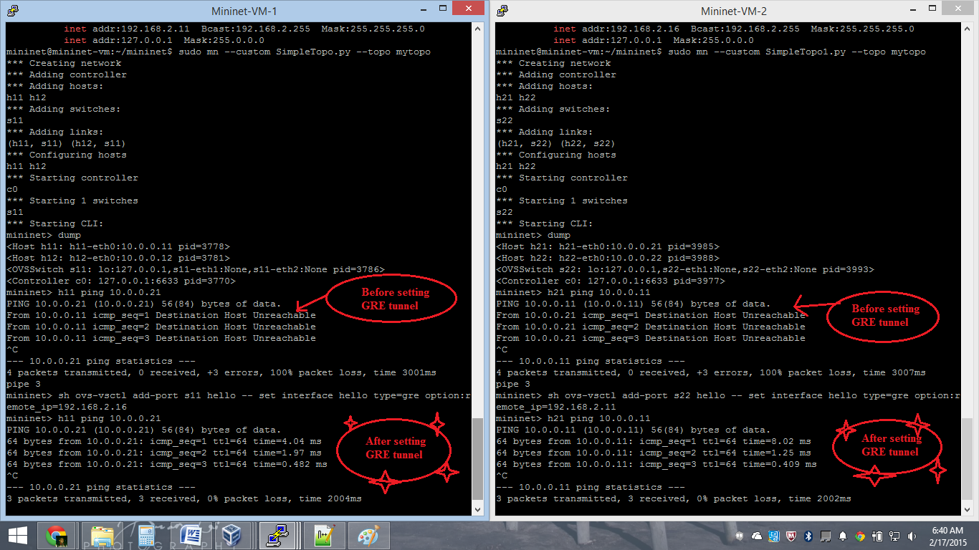

Figure 2